- What Is ReactJs?
- It is Basically JavaScript Library
- It is use to make Ui (Front-end)
- Developed By Meta In 2013
- Components Base Architecture

- JS Essentials
- Basic (Variables, Datatype, Loops ,Condition, Etc.)
- Function (Arrow, Return)
- Array (Map, Filter, Reduce, For Each, Destructor)
- Object
- ES6+Features (let, Const, Etc.)
- Asynchronous JavaScript (Promise, Fetch API, Async Await)

NOTE:-
- Library
- GSAP
- LENIS
- REACT JS

- Framework
  - NextJs
  - Angular

  - Import & Export
- Export :-
- // const a = 20
- // const arr = [10, 20, 30, 40, 50]
- // export default arr

- const user = "Zaid"
- export const age = 89
- export const skills = ['Frontend', 'backend']

- export default user

- // export default {a,arr}

- /*Export 2 Types

- named
- = const arr = [10, 20, 30, 40, 50]
- = export default arr
- = import {arr} from '.app.js'
- Default

- */

- Import:-
- // import a from './app.js'
- // console.log(a)

- // import arr from './app.js'
- import {age,skills} from './app.js'
- // console.log(arr)
- console.log(age,skills)

- Real Dom vs Virtual Dom
- Real Dom
- The Real Dom Is The actual Structure of the webpage created by the browser.
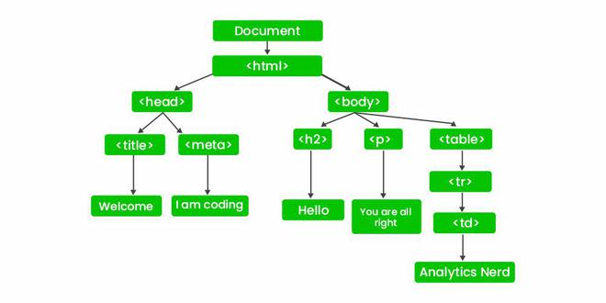
- Virtual Dom
- The Virtual Dom is a lightweight copy of the Real Dom Stored in memory as JavaScript Objects.
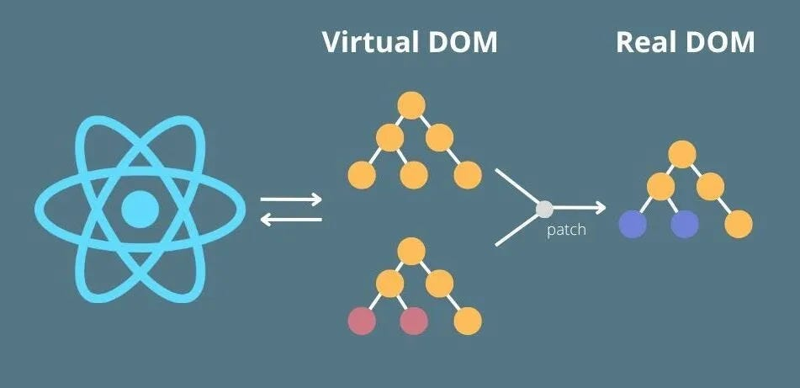

- JSX ( JavaScript XML )
HTML + JavaScript
- It’s Combines Of Html & JavaScript
- JSX stands for JavaScript XML. It is a syntax used in React to write HTML-like code inside JavaScript.
const element = <h1>Hello World</h1>;

App.jsx > main.jsx > index.css > index.html
Child > Dad > Father
rafce = React Arrow Function Component Export

